Q1. Define Data Quality in the context of ETL pipelines. Why is it more than just data cleaning?
Data Quality refers to the accuracy, completeness, consistency, validity, uniqueness, and reliability of data throughout the ETL process.
It is more than just data cleaning because it also includes:
- Validating business rules
- Ensuring data consistency across systems
- Maintaining referential integrity
- Detecting duplicates
- Monitoring data accuracy and completeness
Example: Checking whether Customer_ID exists in the master table is a data quality activity, not merely cleaning.

Q2. Explain why poor data quality leads to misleading dashboards and incorrect decisions.
Poor data quality can cause:
- Incorrect KPIs and reports
- Wrong revenue calculations
- Duplicate transactions
- Missing customer information
- Invalid trend analysis
Example: If duplicate sales records exist, total sales will be overstated, causing management to make incorrect business decisions.

Q3. What is duplicate data? Explain three causes in ETL pipelines.
Duplicate data means multiple records represent the same business transaction.
Causes:
- Multiple data loads
  - Same file loaded more than once.
- Source system errors
  - Data entered repeatedly by users.
- Improper join logic
  - Incorrect joins creating duplicate records during transformation.

Q4. Differentiate between exact, partial, and fuzzy duplicates.
Type | Description | Example
Exact Duplicate | All fields are identical | Rows 201, 203, and 208
Partial Duplicate | Some key fields match | Same customer but different amount
Fuzzy Duplicate | Similar but not identical values | "Rahul Mehta" vs "Rahul M."

Q5. Why should data validation be performed during transformation rather than after loading?
Validation during transformation:
- Detects issues early
- Prevents bad data from entering target systems
- Reduces correction effort
- Improves report accuracy
If validation occurs after loading, incorrect data may already affect dashboards and business reports.

Q6. Explain how business rules help in validating data accuracy. Give an example.
Business rules define acceptable data conditions.
Examples:
- Quantity must be greater than 0.
- Transaction Amount cannot be NULL.
- Customer Name cannot be "N/A".
From the dataset:
Txn_ID | Issue
205 | Quantity = NULL
206 | Customer_Name = N/A
206 | Txn_Amount = NULL
These records violate business rules and should be flagged.

Question 7 : Write an SQL query on Sales_Transaction to list all duplicate keys and their counts using the business key (Customer_ID + Product_ID + Txn_Date + Txn_Amount )

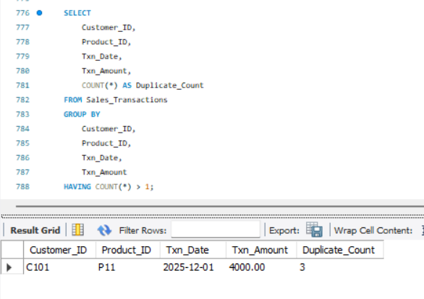

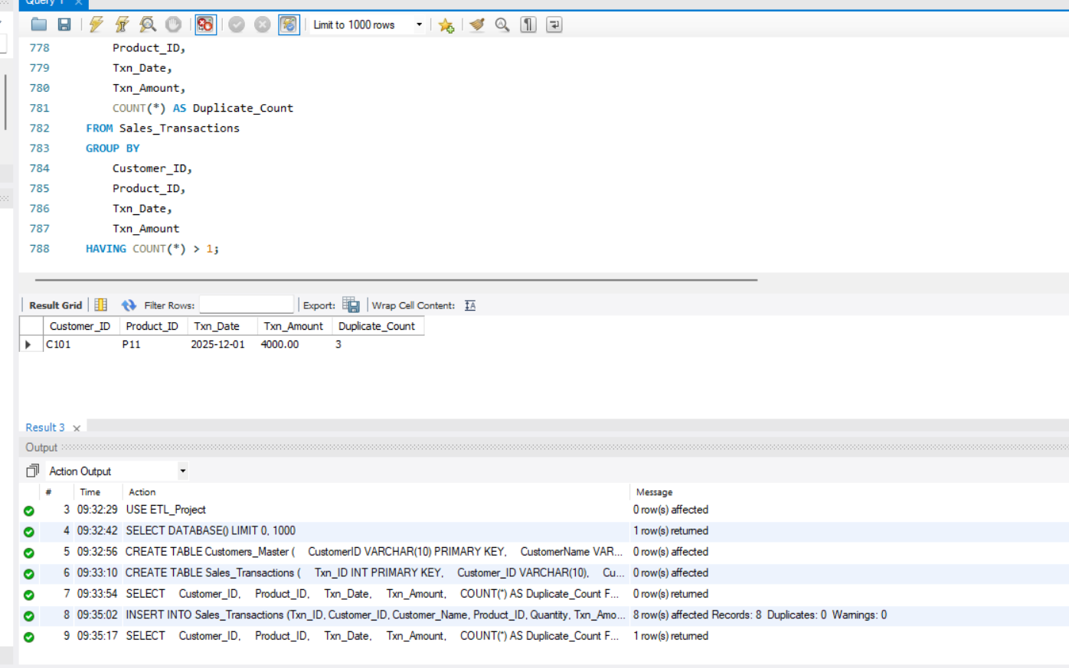

Question 8 : Enforcing Referential Integrity Assume the following customer_master table:

